  - Chronic respiratory illness

Infant Wheezing Review
Practicing pediatricians in India

Source Content
# Infant Wheezing in Primary Pediatric Practice
Recurrent wheeze in infancy requires careful history, examination, and follow-up rather than automatic labeling as asthma. Pediatricians should document age at onset, feeding pattern, growth, family history of atopy, exposure to tobacco smoke, previous hospital visits, and response to bronchodilator trials when they are clinically appropriate.
Red flags include poor weight gain, persistent focal chest signs, hypoxemia, recurrent severe infections, choking episodes, and symptoms beginning from birth. These features should prompt careful reassessment, referral, or investigation based on the clinical setting.
Parent counseling should explain when to seek urgent care, how to monitor work of breathing, and why unnecessary antibiotics or unverified cough mixtures should be avoided. The counseling plan should remain practical for families who may have limited access to urgent pediatric care.
Follow-up is important because the pattern of symptoms over time often clarifies whether the child has episodic viral wheeze, early asthma, aspiration risk, airway anomaly, or another chronic respiratory illness. Documentation should remain conservative and should not include unsupported dosing, vaccine schedule, or treatment-policy claims.
For a Mini CME document, useful visuals include a conservative topic map, a visit-level checkpoint flow, and an audit trail that separates supplied content from claims requiring source verification. Any production version should verify all medical claims against authoritative pediatric sources before publication.
Additional pasted notes:
Additional production note: preserve the conservative framing and avoid dosing claims.
Figure 1. Clinical topic map
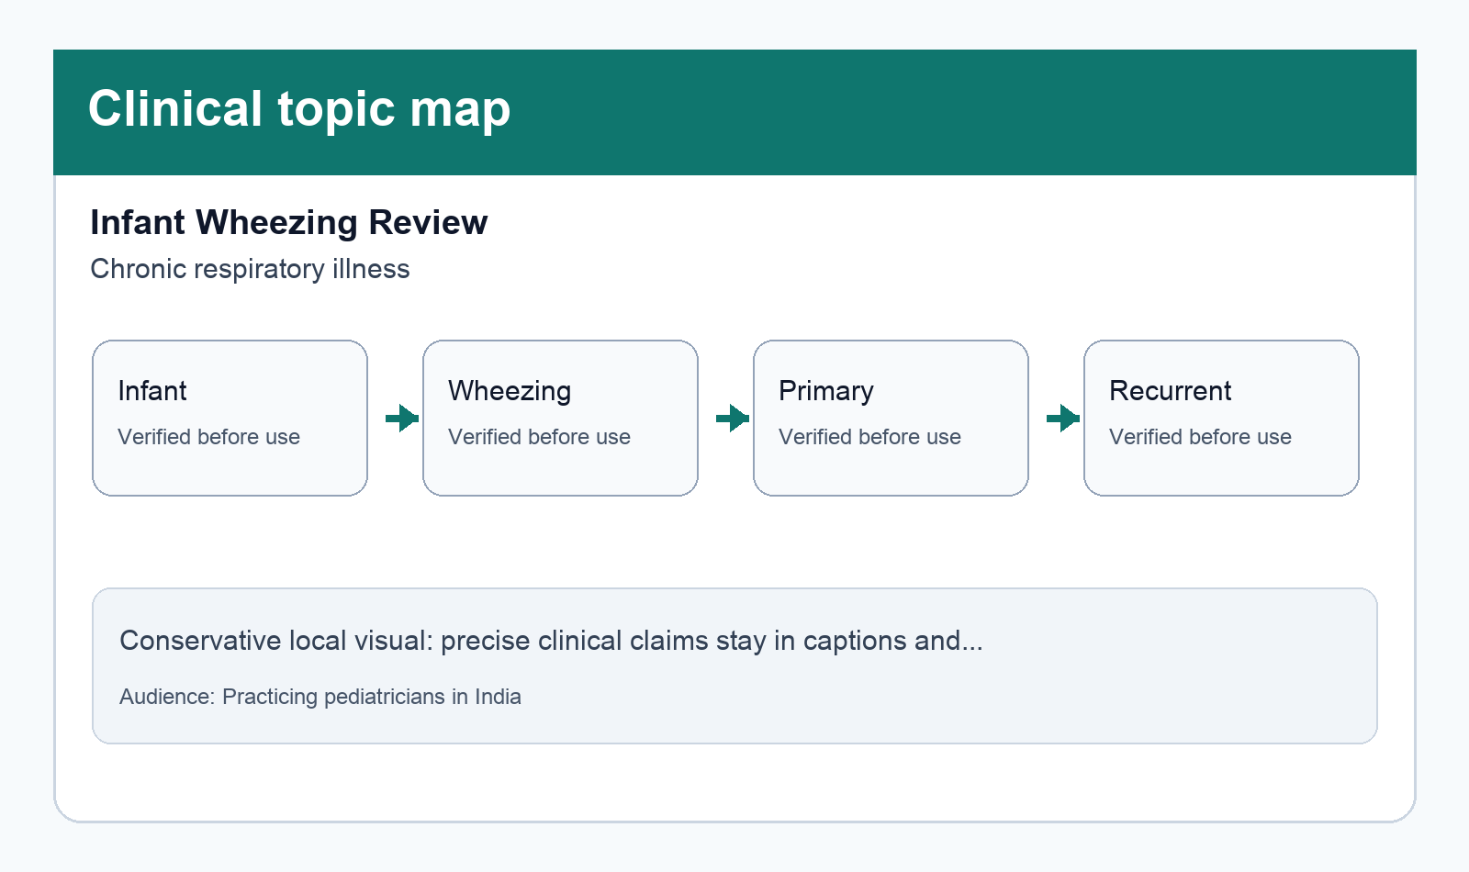
A compact visual map of the topic, classification, audience, and recurring source-content themes.
Figure 2. Practice checkpoint flow
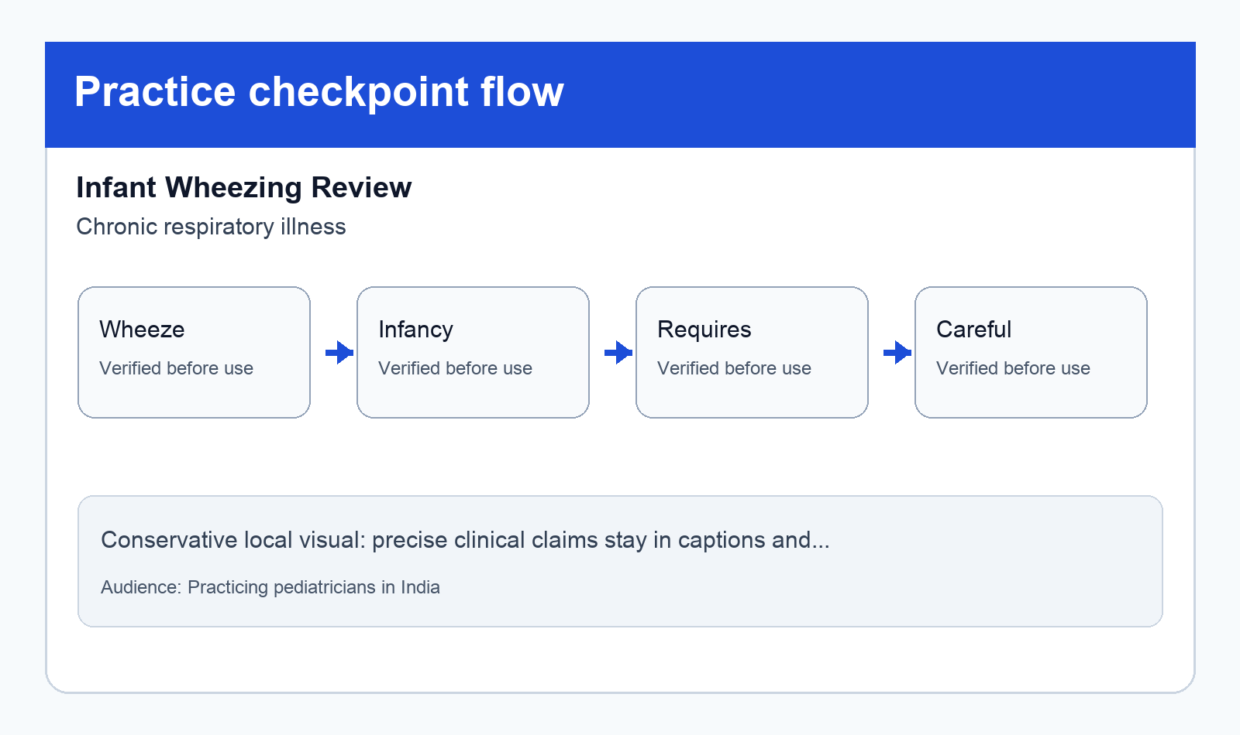
A conservative workflow-style reference showing assessment, explanation, documentation, and follow-up checkpoints.

Why These Illustrations Were Used
Figure | Relevance and Use
Figure 1. Clinical topic map | Clinical topic map gives pediatricians in India a quick reference anchor while preserving the supplied article content and avoiding unsupported claims inside the image.
Figure 2. Practice checkpoint flow | Practice checkpoint flow gives pediatricians in India a quick reference anchor while preserving the supplied article content and avoiding unsupported claims inside the image.

Sources Consulted
- User supplied content: /Users/inditech-tech/Documents/mini-cme-illustrations-creator-handoff/media/mini_cme_illustrations/uploads/infant_wheezing_sample.md | Verified: Content was extracted and preserved from the submitted source material.; Locally generated figures avoid unsupported dosing, schedule, or treatment claims. | Used for: Document body and conservative figure captions/rationales | Accessed: 2026-05-19
- Nelson Textbook of Pediatrics | Verified: Queued for Codex research verification in the stored task prompt. | Used for: Must-use source requested by the submitter | Accessed: 2026-05-19

